We will engage in a variety of role play experiences; we will explore lots of open-ended resources to enhance our imaginative skills. We will create a ‘Toy Shop’, ‘Elves workshop’, ‘Nativity Stable’ and a ‘Shoe shop’.

We will explore musical instruments and different ways to play them (loud, quiet, soft, hard, fast, slow). We will take about how the different sounds make us feel. For example, slow might make us feel sleepy and fast might make us feel excited.

We will learn about different faiths, beliefs and celebrations. We will learn about different festivals that happen in December such as Diwali and Hannukah.



We will explore different toys and how toys work. We will talk about our favourite toys and design our own toys. In our role play area, we will create our own ‘Toy Shop’ and look at categorising different toys by their size, shape and colour. We will use this topic to help us count up to 10 forwards and backwards and match numerals to quantities.

We will explore colour and how colours can be changed. We will be colour mixing with lots of different materials, such as paint, coloured shaving foam, coloured water, ice and playdough.

We will explore colour and how colours can be changed. We will be colour mixing with lots of different materials, such as paint, coloured shaving foam, coloured water, ice and playdough.

The children will take part in our Christmas Trail, we will have lots of activities throughout the nursery for children to take part in. These activities include: writing letters to Father Christmas, making Christmas calendars, making Christmas cards and Christmas decorations and we will also enjoy a special visit from Father Christmas!

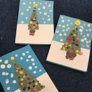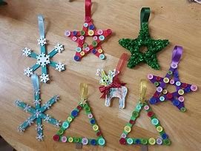

We will be learning our Christmas Performance songs. We will perform these in our nativity performance at St Peter’s Church!

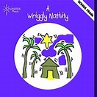

We will be learning about the season ‘winter’ and what different signs to look out for. What clothing we need to wear and we will be talking about the weather changes.



**Toys and Celebrations!**

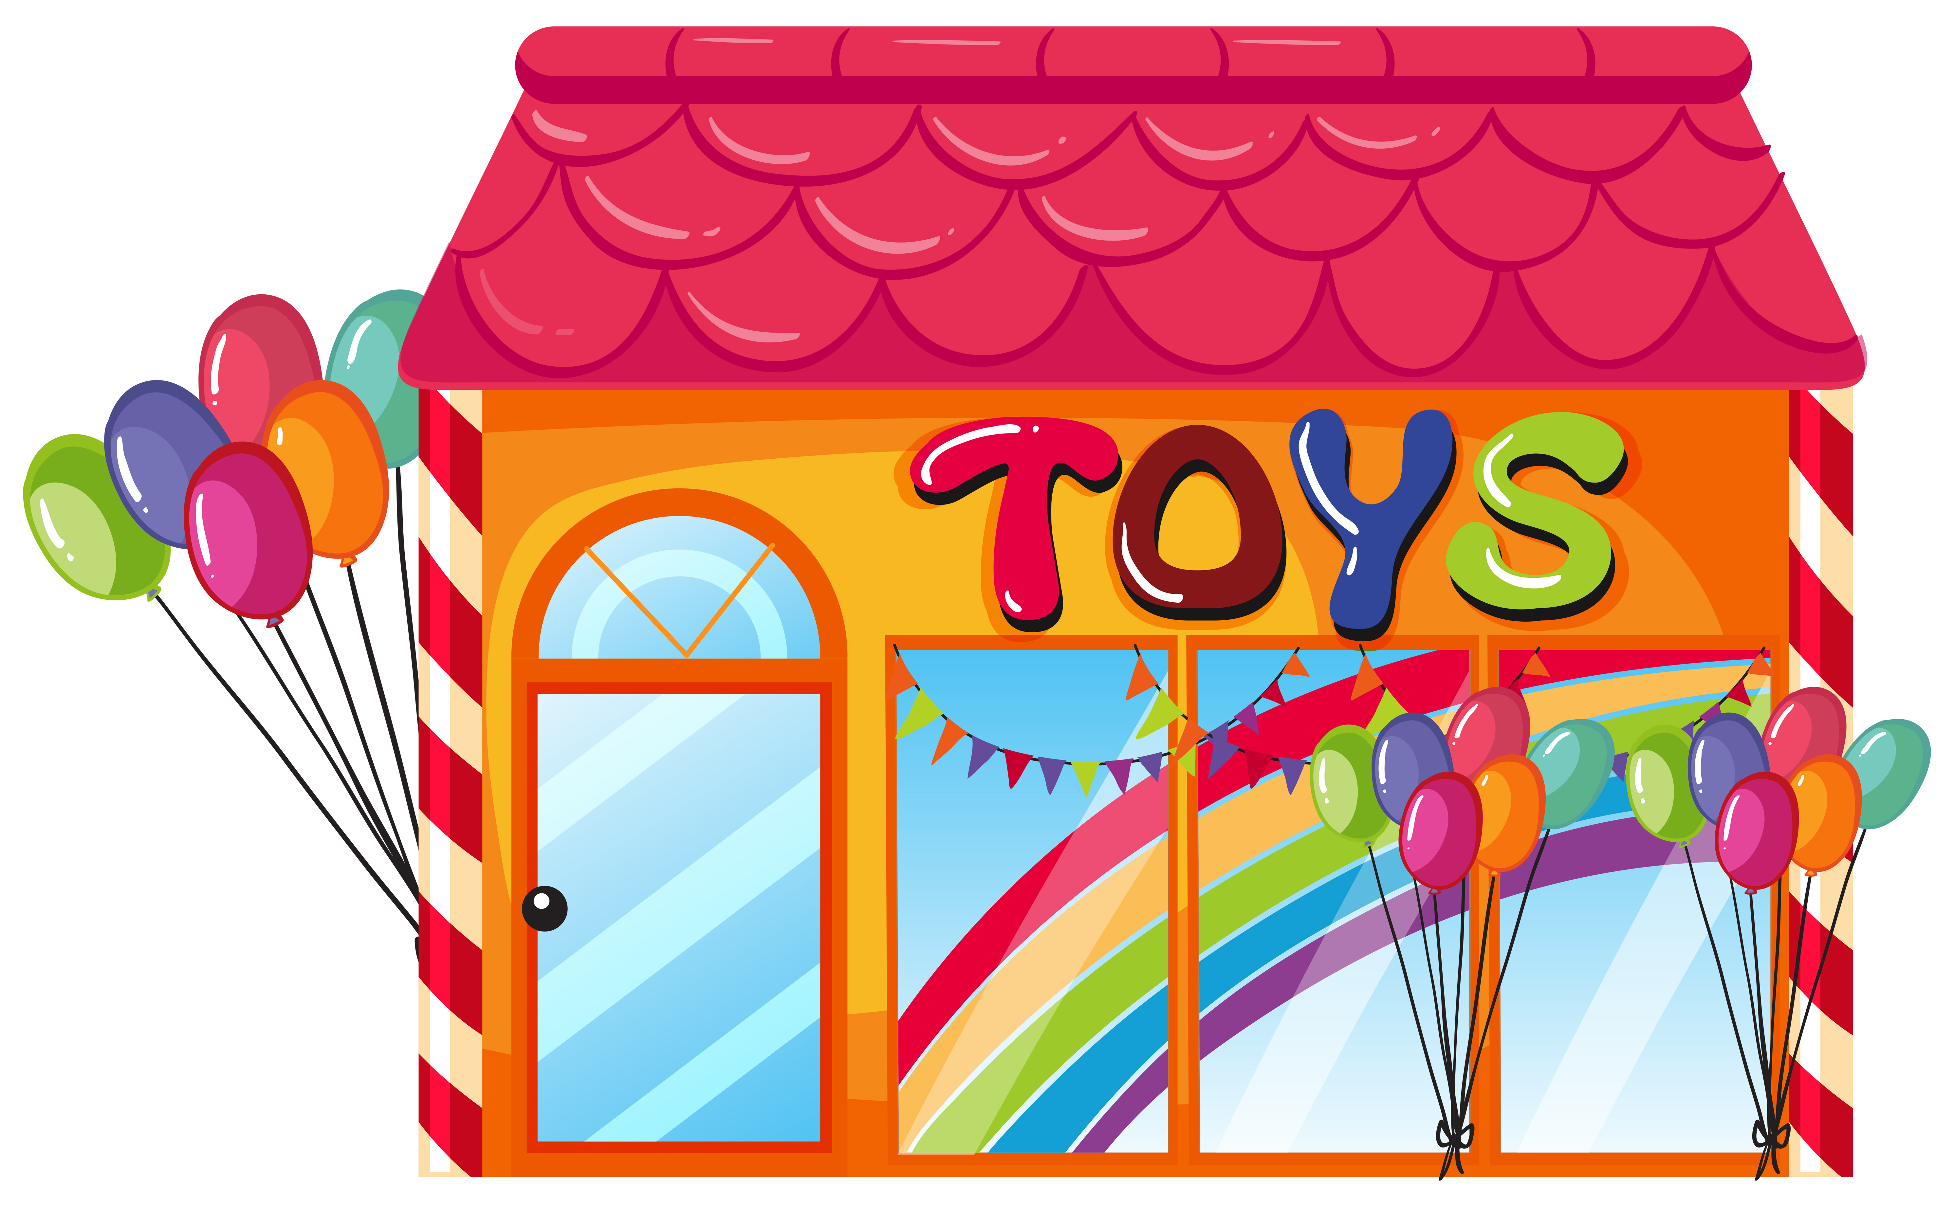

Out theme is based around these stories:

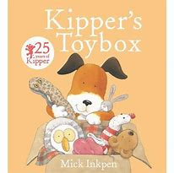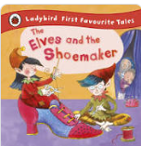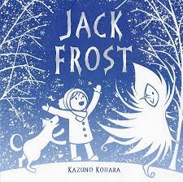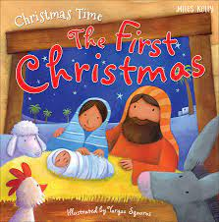

We will be listening to and retelling these stories in lots of different ways.

**Nursery Home/School Learning Plan**

**Our theme for this half term is ‘Toys and Celebrations’ and ‘Seasonal Change’. Here are some of the activties we will be exploring in nursery. Please support my learning by also helping me at home.**